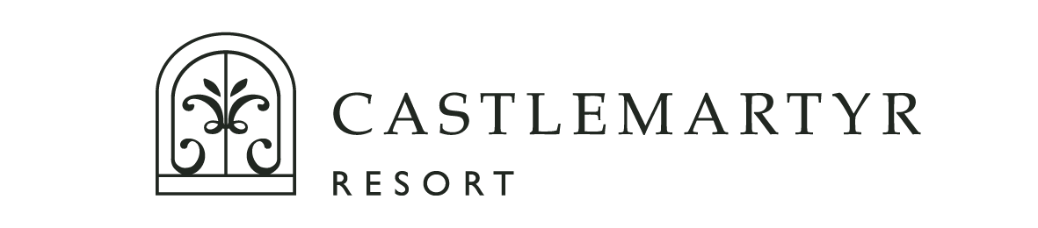

Christmas Menu 2023
(The Ball Room and The Manor House Private Dining)

Butternut Soup, Roast Spiced Chestnut

Ballycotton Smoked Haddock Feuillette, Creamed Spinach, Wholegrain Mustard Velouté

Red Onion Tart Tatin, Saffron Cooked Potato, Goats Curd, Balsamic Pumpkin Seeds

Spiced Beef, Honey Roasted Carrots, Hazelnut, Mizuna Cress
***

Roast Turkey and Ham, Sausage Stuffing, Roast Parsnip, Brussel Sprouts, Bread Sauce

Salmon Wrapped in Parma Ham, Pearl Barley, Green Bean, Cherry Tomato, Basil Butter

Roast Hereford Sirloin, Butternut and Mushroom Pithivier, Red Wine Jus

Pan Fried Cod, Roasted Red Pepper, Asparagus, Chive Velouté
***

Christmas Pudding, Jameson Anglaise, White Chocolate Ice Cream

Poached Plum, Almond Financier Cake, Kirsch Parfait

Chocolate Marquis, Cookie Crumb, Almonds, Vanilla Ice Cream

White Chocolate Cheesecake, Cranberry Compote, Honeycomb
***

Served with Freshly Brewed, Tea, Coffee and Petit Fours

3 Courses €75

Please select 1 x Starter

Please select 2 x Main Courses

Please select 1 x Dessert

A Silent Vegetarian Option will be included on the Starter Course and Main Courses

